**727721EUIT126**

**RASIKA B**

**Day 4**

**Class Exercise**

**Task1:**

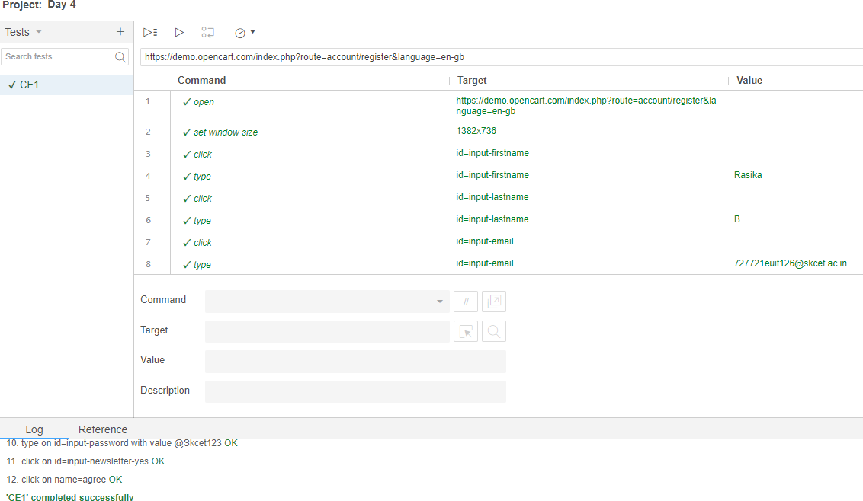

**Task2:**

**package** com.Test.Test;

**import** org.openqa.selenium.By;

**import** org.openqa.selenium.WebDriver;

**import** org.openqa.selenium.WebElement;

**import** org.openqa.selenium.chrome.ChromeDriver;

**import** org.openqa.selenium.chrome.ChromeOptions;

**import** io.github.bonigarcia.wdm.WebDriverManager;

**public** **class** CE_Task2 {

**public** **static** **void** main( String[] args ) **throws** InterruptedException

{

ChromeOptions co=**new** ChromeOptions();

co.addArguments("--remote-allow-origins=*");

WebDriverManager.*chromedriver*().setup();

WebDriver driver=**new** ChromeDriver(co);

//

driver.navigate().to("https://demo.opencart.com/index.php?route=account/register&language=en-gb");

WebElement fname=driver.findElement(By.*id*("input-firstname"));

fname.sendKeys("RASIKA");

WebElement lname=driver.findElement(By.*id*("input-lastname"));

lname.sendKeys("B");

WebElement email=driver.findElement(By.*id*("input-email"));

email.sendKeys("727721euit126@skcet.ac.in");

WebElement pass=driver.findElement(By.*cssSelector*("input#input-password"));

pass.sendKeys("skcet");

Thread.*sleep*(300);

WebElement sub=driver.findElement(By.*id*("input-newsletter-yes"));

sub.click();

}

}

**Task3:**

**package** com.Test.Test;

**import** org.openqa.selenium.By;

**import** org.openqa.selenium.JavascriptExecutor;

**import** org.openqa.selenium.WebDriver;

**import** org.openqa.selenium.chrome.ChromeDriver;

**import** org.openqa.selenium.chrome.ChromeOptions;

**import** io.github.bonigarcia.wdm.WebDriverManager;

**public** **class** CE_Task3 {

**public** **static** **void** main( String[] args ) **throws** InterruptedException

{

ChromeOptions co=**new** ChromeOptions();

co.addArguments("--remote-allow-origins=*");

WebDriverManager.*chromedriver*().setup();

WebDriver driver=**new** ChromeDriver(co);

driver.get("https://demo.opencart.com/index.php?route=checkout/voucher&language=en-gb");

driver.findElement(By.*xpath*("//input[@id=\"input-to-name\"]")).sendKeys("Rasika");

JavascriptExecutor js=(JavascriptExecutor) driver;

js.executeScript("window.scroll(0,500)", "");

Thread.*sleep*(5000);

driver.findElement(By.*xpath*("//input[@id=\"input-theme-6\"]")).click();

}

}

**Task4:**

**package** com.Test.Test;

**import** org.openqa.selenium.By;

//import org.openqa.selenium.By;

**import** org.openqa.selenium.JavascriptExecutor;

**import** org.openqa.selenium.WebDriver;

**import** org.openqa.selenium.chrome.ChromeDriver;

**import** org.openqa.selenium.chrome.ChromeOptions;

**import** io.github.bonigarcia.wdm.WebDriverManager;

**public** **class** CE_Task4 {

**public** **static** **void** main( String[] args ) **throws** InterruptedException

{

ChromeOptions co=**new** ChromeOptions();

co.addArguments("--remote-allow-origins=*");

WebDriverManager.*chromedriver*().setup();

WebDriver driver=**new** ChromeDriver(co);

driver.get("https://j2store.net/free/");

driver.manage().window().maximize();

JavascriptExecutor js=(JavascriptExecutor) driver;

js.executeScript("window.scroll(0,1000)", "");

Thread.*sleep*(3000);

driver.findElement(By.*xpath*("/html/body/div[2]/div/div[2]/div/div/div/div/ul/li[1]/h4/a")).click();

driver.navigate().back();

driver.navigate().forward();

driver.navigate().refresh();

driver.close();

}

}

**Task5:**

**5.1**

**package** com.Test.Test;

**import** org.openqa.selenium.By;

**import** org.openqa.selenium.JavascriptExecutor;

**import** org.openqa.selenium.WebDriver;

**import** org.openqa.selenium.chrome.ChromeDriver;

**import** org.openqa.selenium.chrome.ChromeOptions;

**import** io.github.bonigarcia.wdm.WebDriverManager;

**public** **class** CE_Task5 {

**public** **static** **void** main(String args[])**throws** InterruptedException

{

ChromeOptions co=**new** ChromeOptions();

co.addArguments("--remote-allow-origins=*");

WebDriverManager.*chromedriver*().setup();

WebDriver driver=**new** ChromeDriver(co);

driver.get("https://j2store.net/free/");

driver.manage().window().maximize();

String currentUrl=driver.getCurrentUrl();

String exceptedUrl="https://j2store.net/free/";

**if**(currentUrl.equals(exceptedUrl))

{

System.***out***.println("Url Matched");

}

**else**

{

System.***out***.println("Url Not Matched");

}

JavascriptExecutor js=(JavascriptExecutor) driver;

js.executeScript("window.scroll(0,1000)", "");

driver.findElement(By.*xpath*("/html/body/div[2]/div/div[2]/div/div/div/div/ul/li[1]/h4/a")).click();

String currentUrl1=driver.getCurrentUrl();

String exceptedUrl1="https://j2store.net/free/index.php/shop?filter_catid=11";

**if**(currentUrl1.equals(exceptedUrl1))

{

System.***out***.println("Url Matched");

}

**else**

{

System.***out***.println("Url Not Matched");

}

}

}

**Output:**

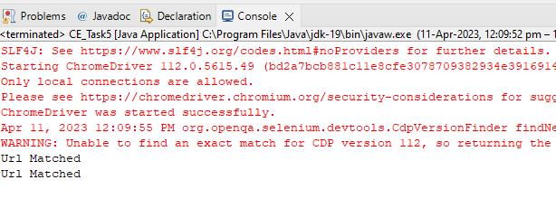

**5.2**

**package** com.Test.Test;

**import** java.util.List;

**import** org.openqa.selenium.By;

**import** org.openqa.selenium.JavascriptExecutor;

**import** org.openqa.selenium.WebDriver;

**import** org.openqa.selenium.WebElement;

**import** org.openqa.selenium.chrome.ChromeDriver;

**import** org.openqa.selenium.chrome.ChromeOptions;

**import** io.github.bonigarcia.wdm.WebDriverManager;

**public** **class** CE_Task_5_2 {

**public** **static** **void** main(String args[])**throws** InterruptedException

{

ChromeOptions co=**new** ChromeOptions();

co.addArguments("--remote-allow-origins=*");

WebDriverManager.*chromedriver*().setup();

WebDriver driver=**new** ChromeDriver(co);

driver.get("https://j2store.net/free/");

JavascriptExecutor js=(JavascriptExecutor) driver;

js.executeScript("window.scroll(0,1000)", "");

driver.findElement(By.*xpath*("/html/body/div[2]/div/div[2]/div/div/div/div/ul/li[1]/h4/a")).click();

List<WebElement> li=driver.findElements(By.*xpath*("//h2[@itemprop=\"name\"]"));

**for**(WebElement link:li)

{

System.***out***.println(link.getText());

}

}

}

**Output:**

